SPECIALIST REPORT

FRONT OF PROPERTY IMAGE

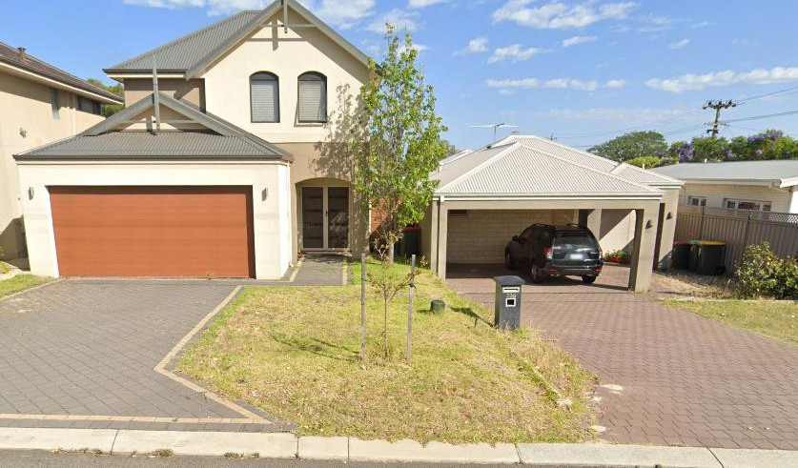

|  |  |
| --- | --- |
| **Overview** | |
| **Scope of work (Select):** (Leak Detection, Roof Report, Make Safe Report, etc.) | |
| **CLAIM DETAILS** | |
| **I&R work Order/Purchase Number** | UBS-xxxxx |
| **Site contact** |  |
| **Job Address** |  |
| **INSPECTION DETAILS** | |
| **Date of Inspection** |  |
| **Time of inspection** |  |
| **Inspection Completed By** |  |
| **PROPERTY DETAILS** | |
| **Building type** | Brick veneer home/Concrete panel warehouse etc |
| **Construction type** | Single story residential home/Multi level apartment/Warehouse etc |
| **Roof Type** | Terracotta tile/Aluminum sheet etc |
| **Estimated age of property** |  |
| **MAKE SAFE DETAILS (If applicable)** | | |
| **Make safe work Order/Purchase Number** | |  |
| **Make safe instruction from UBS** | | Roof leaking above loungeroom – Attend to make safe |
| **Make safe findings** | | Found broken roof tile above area of moisture damage. |
| **Make safe works completed** | | Replaced broken roof tiles with spare supplied by insured. Cleared gutter of debris |
| **Date make safe completed** | |  |

©Unique Building Services – Trade Contractor Leak Detection Report - Example Page 1 of 5

|  |  |
| --- | --- |
| **CLAIMED DAMAGE DETAILS** | |
| What damages are evident? | Staining to ceiling |
| Area of damages | Approx 2m2 |
| Location of damages (inc dimensions) | 1st Bedroom (3m x 3m x 2.4m) |
| Damage timeframe | Multiple/single event. Long term etc |

|  |  |
| --- | --- |
| **CAUSATION DETAILS** |  |
| Cause identified? | Yes |
| What has caused the damage? | Rain water ingress has occurred via a broken roof tile |
| Why has the cause occurred? | Cracked tile consistent with foot traffic from AC installers |
| Are any compliance issues/building defects contributing to the cause? If yes - Specify |  |
| Summary of how cause was determined. Specify other investigation completed/supporting factors. |  |

|  |  |
| --- | --- |
| **MAINTENANCE/CAUSE RECTIFICAITON DETAILS** |  |
| Are maintenance works required to prevent reoccurrence of damage? If yes, specify scope of works. |  |
| Maintenance scope of works: | Estimated cost: |
| Were any maintenance defects identified which are not impacting the claim? If yes, specify. |  |

|  |  |
| --- | --- |
| **Conclusion** |  |
| Summary of findings and final conclusion: | |
| Any recommended further investigations: |  |
| Special notes: |  |

|  |  |  |  |
| --- | --- | --- | --- |
| **ROOF REPORT DETAIL (If applicable)** |  | | |
| Approximate age of the roof: | 40 | | |
| General roof condition: | Poor | | |
| Roof pitch above area of damage: | 5.2 | | |
| Roof pitch required to be in accordance with the | 5 | | |
| minimumprofile / product (degrees): |
| Roof pitch installed in accordance with the minimum profile / | Yes | | |
| product as per NCC 2019 Building Code of Australia 3.5.1.3: |
| Roof condition above area of damage: | Poor | | |
| Roof profile: | Tray deck (Cliplok) □  Other □ | Tray deck (Pierced fixing) □  Corrugated ☑ | |
| Tray deck sheets turned down sufficiently at gutter end: | N/A | | |
| Roof sheets weathered sufficiently at high end: | No | | |
| Roof sheet condition: | Good □  Poor ☑  Split □ | Fair for age □ Creased □ Corroded ☑ | |
| Pierced fixing (screwed) rubber seal condition: | Good □ | Deteriorated ☑ | |
| Over tightened □ |  | |
| Roof sheets engage rear of gutter by min 50mm: | N/A | | |
| Sarking installed: | No | | |
| Sarking extends to gutter line: | N/A | | |
| Storm created openings: | No | | |
| Ceiling insulation installed: | No | | |
| Ceiling insulation damaged: | N/A | | |
| Approximate amount of damaged insulation (Sqm): |  |  | |
| Roof penetrations in accordance with, SA HB 39 section 8.6: | N/A | | |
| Spouting with no permanent ponding, in accordance with | N/A | | |
| SAHB 39 5.6 (f): |
| Spouting outlet / downpipe clear; | N/A | | |
| Sufficient down pipes as per NCC 2019 3.5.3.5 | N/A | | |
| Sufficient provision for overflow of eave gutter, | N/A | | |
| inaccordance with AS/NZS 3500.3 Appendix G: |
| Alternative overflow (a performance solution is required): | N/A | | |
| Adequate flashing covers, in accordance with SA HB 39  8.1.4:Horizontal 150mm Vertical 100mm | No | | |
| Fixing seal application in accordance with SAA HB 39  2.9:25mm lap, sealed between with 40mm fixing spaces | No | |
| Adequate fixing spacing, wall flashings in accordance with  SAHB 39 8.4: Compression flashing 100mm centers | No | |
| Correct downpipe spreader, in accordance with SAA HB  395.7.7: | N/A | |
| Reason down pipe spreader is non-compliant: | Spreader design non- Exceeds maximum compliant □ allowable catchment area  □  No sarking present □ Discharges onto flashing □  Discharges against the Discharges into a valley direction of flow □ gutter □  N/A ☑ | |
| Valley gutter: | N/A | |
|  |  | |
| Pitch of roof discharging into valley gutter not less than  12.5degrees as per AS 3500.3 3.6: | N/A | |
| Valley gutter side angle not less than 16.5 degrees as per AS  3500.3 3.6: | N/A | |
| Valley gutter roof catchment area does not exceed 20 sqm as per AS 3500.3 3.6: | N/A | |
| Any storm related damage to the roof: | No | |
| Windows, doors or any other opening spray test: | **N/A** | |

|  |  |
| --- | --- |
| **Leak detection report detail (If applicable)** | |
| **Pressure Test Domestic Cold Line** | PASSED |
| **Pressure Test Domestic Hot Line** | PASSED |
| **Pressure at Time of Testing** | 500 |
| **Thermal Imaging** | FAILED |
| **INSPECTION LOCATION** | Laundry |
| **Breach Pressure Test/Water Connections** | Trough – PASSED |
| **Waste Piping Connections** | Trough – PASSED |
| **Waste and Water Connections** | Washing Machine – PASSED |
| **Condensation Piping** | Dryer – PASSED |

|  |  |
| --- | --- |
| **Photos** | |
|  | Mains pressure tested  External wall testing  Upstairs window has moved allowing water ingress  Cracked render |
|  | Cracked render |

©Unique Building Services – Trade Contractor Leak Detection Report - Example Page 3 of 5

|  |  |
| --- | --- |
|  | Spray testing  Water ingress to window |
|  | Damages |

©Unique Building Services – Trade Contractor Leak Detection Report - Example Page 4 of 5

|  |  |
| --- | --- |
|  | Thermal Imaging |
|  | Laundry overview  Water points |

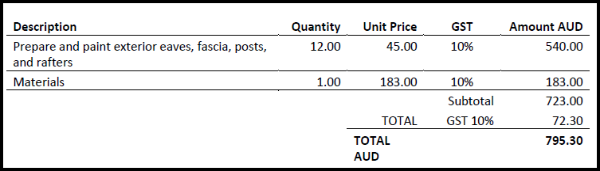

©Unique Building Services – Trade Contractor Leak Detection Report - Example Page 5 of 5